A
SYNOPSIS REPORT
On
SportQuest: Online Sports Learning Platform

Submitted in partial fulfilment of the requirements of the degree of
BACHELOR OF TECHNOLOGY


Submitted by
MD HASSAN (22BTCS012HY)
MD SAJJAD ANSARI (22BTCS029HY)
TOUSIF TARIQUE (23BLCS008HY)

Under the Supervision Of
PROF. PRADEEP KUMAR
Head of Dept. CS&IT
MANUU
Department of Computer Science & Information Technology
School of Technology
Maulana Azad National Urdu University
Hyderabad

Problem Statement
The absence of accessible, comprehensive, and engaging resources for learning and excelling in different sports restricts the growth of aspiring athletes and sports lovers. Conventional learning methods tend to be disjointed, with limited access to expert guidance, immersive training experiences, and personalized feedback.

Objective and Scope of the Project
Objective:
- The objective is to develop a comprehensive online platform that equips users with the essential tools, knowledge, and support needed to learn and excel in a variety of sports.
- Providing roadmaps to guide users on their potential to pursue sports professionally.
Scope:
- Providing comprehensive coverage of various sports, including in-depth information on methods, techniques, rules, regulations, and terminology.
- Delivering beginner courses, pre-recorded materials, video analysis, VR technologies, remote instruction, personalized feedback, behavior assessment, and strategy development.
- Making certain that the platform remains user-friendly, accessible, and consistently updated.
- Providing expert evaluations to guide users on their potential to pursue sports professionally.

Methodology
- Research & Planning:
  - Conduct market research to identify user needs and preferences.
  - Define project goals and create a detailed project plan.
- Content Development:
  - Collaborate with sports experts to create comprehensive content for each sport.
  - Develop instructional videos, tutorials, and course materials for beginners.
- Technology Integration:
  - Implement VR technologies for immersive training experiences.
  - Develop video analysis tools for performance feedback.
  - Set up remote teaching capabilities for live coaching sessions.
- Platform Development:
  - Design and develop the user interface (UI) for ease of navigation.
  - Integrate content and tools into the platform.
  - Perform rigorous testing to ensure functionality and user experience.
- Launch & Marketing:
  - Launch the platform in phases to gather user feedback and make improvements.
  - Implement marketing strategies to promote the platform and attract users.

Hardware & Software to be used

Hardware Requirement:
To ensure smooth development and deployment of the online sports learning platform, the following hardware components are required:

Component Specification

Processor Intel Core i3/i5/i7 or AMD Ryzen 3/5/7 (or higher)

RAM Minimum 4GB (8/16GB recommended for better performance)

Storage Minimum 256GB SSD (Recommended: 512GB SSD or higher) Server Requirements Cloud hosting (AWS, Google Cloud, or Azure)
Internet Connectivity High-speed internet for real-time transactions

Software Requirement:

The project requires a combination of frontend, backend, and database technologies along with development tools.

Category Software/Technology

Operating System Windows 7/10/11, Linux (Ubuntu), or macOS
Frontend Technologies HTML, CSS, Bootstrap, JavaScript
Backend Technologies Node.js Database MongoDB
Development Tools VS Code, GitHub

Server & Hosting AWS EC2, GoDaddy, Infinity Free

Security Tools SSL/TLS encryption, OAuth, JWT authentication

Application and Future Scope of the Project
Application:
- The platform will serve as a comprehensive resource for learning various sports but mastering it requires real-world practice.
- It will be used by beginners, amateur athletes, coaches, and sports enthusiasts.
- Experts will evaluate user performance and provide guidance on pursuing sports professionally.
Future Scope:
- Continuous content updates and improvements based on user feedback.
- Expansion to include more sports and advanced training modules.
- Integration of AI for personalized training and feedback.
- Collaborations with sports organizations for certification and recognition.
- Development of mobile applications for wider accessibility.

Project Timeline (Gantt chart/ PERT chart)
A simplified Gantt chart focused on the breakdown of task and their approximate timelines for this project.
Phase | Week 1 | Week 2 | Week 3 | Week 4 | Week 5 | Week 6 | Week 7 | Week 8
Research & Planning | X | X
Content Development |  | X | X | X
Technology Integration |  |  |  | X | X | X
Platform Development |  |  |  |  | X | X | X | X
Testing |  |  |  |  |  | X | X | X

An eight-week timeline with more specific milestones:

Week | Phase | Activity
1 | Research & Planning | Initial research and planning
2 | Research & Planning, Content Development | Completion of research, start content development
3 | Content Development | Continue content development
4 | Content Development | Continue content development
5 | Technology Integration | Start technology integration
6 | Technology Integration, Platform Development | Continue technology integration, start platform development
7 | Platform Development | Continue platform development
8 | Testing | Begin testing phase

Entity Relationship Diagram
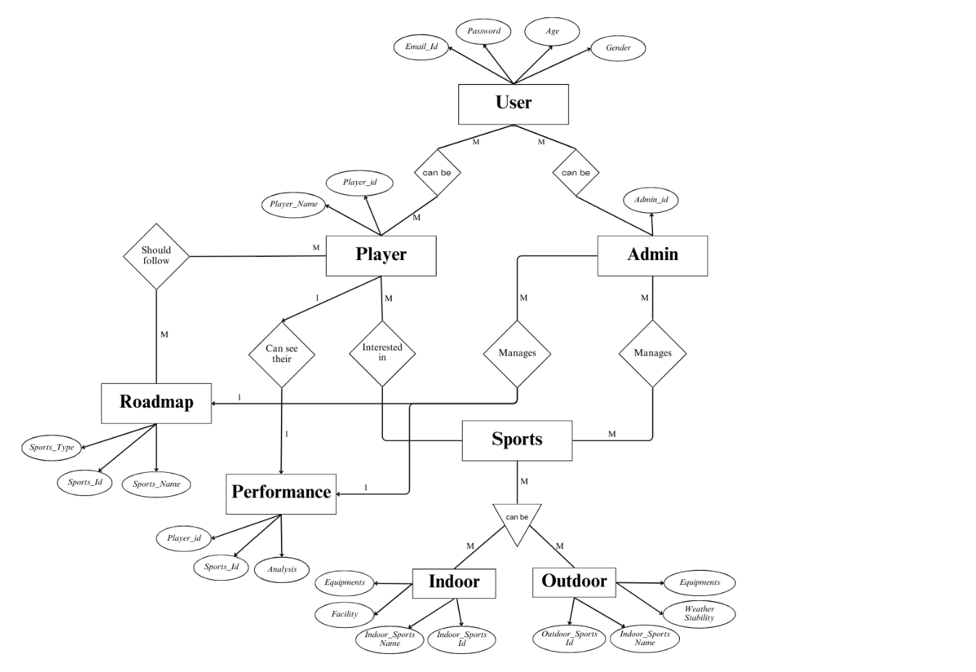

References/Bibliography
[1] P. L. Williams, J. M. Jones, and K. T. Simon, "The role of digital platforms in sports education and coaching," Journal of Sports Education Technology, vol. 15, no. 3, pp. 123-136, Mar. 2023.
[2] R. S. McDonald, "Virtual Reality in Sports Training: A New Era," International Journal of Sports Science & Technology, vol. 22, no. 5, pp. 78-85, May 2022.
[3] T. H. Weber, "Video analysis and feedback mechanisms in athletic training," Journal of Performance Evaluation in Sports, vol. 18, pp. 45-55, Feb. 2021.
[4] Online Sports Academy, https://onlinesportsacademy.com/
[5] iSportz: LEARNING MANAGEMENT SYSTEM (LMS), https://isportz.co/sports/sports-learning-management-system/

